**Monitoring via EVM**

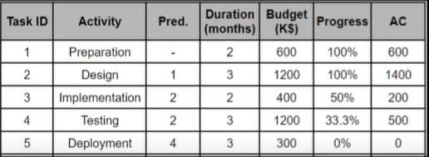

**(After 7 months)**

**Project over budget by 300 K$ (in this moment)**

(Task 2 over budget by 200 K$ + task 3 over budget by 100 K$)

**It’s behind the schedule by 30 days (1 month)**

**(**After 7 months task 3 should be finished, progress of task 4 should be 66.66%)

By the end, the project will be over budget by 500K$

( assuming there no over/under budget for task 5)

* Cost variance(CV) = budgeted cost of work performed (BCWP) - actual cost of work performed (ACWP)

**CV = 2400 K$ - 2700K$ = -300K$**

* Schedule Variance (SV) = Earned Value (EV) – Planned Value (PV)

**SV =56.33% * 3700K$ - 73.33% * 3700K$ = -629K$**

* Cost Performance Index (CPI) = earned value (EV) / actual cost (AC)

**CPI = 56.33%*3700 / 2700 = .77192<1 (over budget)**

* Scheduled Performance Index= earned value (EV) / planned value (PV)

**SPI = 56.33% * 3700K$ / 73.33% * 3700K$ =.7681<1 (behind schedule)**

* Estimate at Completion (EAC) = AC + (BAC - EV)/SPI * CPI(Estimate at Completion equals Actual Costs plus Budget at Completion minus Earned Value divided by Schedule Performance Index times Cost Performance Index)

**EAC = 2700 + (3700 – 2084.21)/.7681 = 4803.61 K$**

NOTES:

**EV** = **Percent complete (actual) x Task Budget**

**PV = Percent complete (planned) x Task Budget**